Assignment -01

Q1 Create the following tables with the given structures and insert sample data as specified :-
(A) SALESPEOPLE
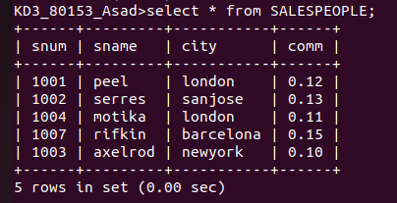

(B) CUSTOMERS

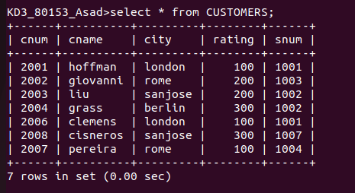

© ORDERS
